# Add code to VSTS Git repository and Pull Request

I had written an article introducing Git feature of Visual Studio Team Services (VSTS) in an article [Visual Studio Online with Git](http://www.dotnetcurry.com/visualstudio/1082/visual-studio-online-vso-with-git). VSTS was called Visual Studio Online (VSO) at that time. In that article, we walked through a scenario of creating a new team project and clone the remote repository and add a new solution to that. In this article, we will look at a different scenario where a solution in a local repository needs to be added to a remote repository. We will also have an overview of a feature in VSTS Git called Pull Request which enables code review before that code is merged from a temporary branch to a master or release branch.

Many a times we begin coding by creating a local solution which is not added to source control. Sometimes we may also download a project created by someone else to be used in our solution. In such situations, we need to first add the solution to local repository and then synchronize it with the remote repository on the VSTS.

Let us first create a solution and a project under that. Those are not added to the source control at the time of creation. We can do some code edits in the files. Let us now add the project to a local Git repository. For that right click on the solution and select add to source control. It is also possible to create a new git repository and add the solution to that repository while creating the project.

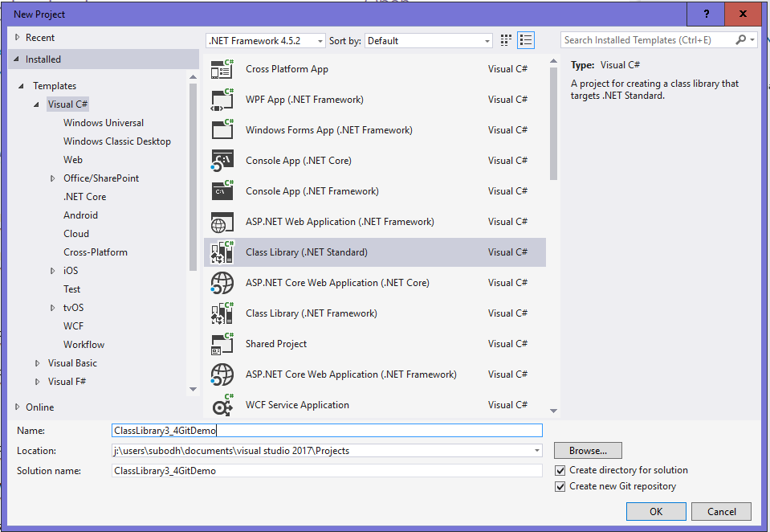

*Figure 1: Create new project and new git repository*

If we look at the team explorer now, it will show various git operations possible at this moment.

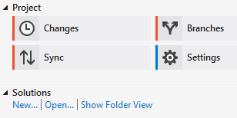

*Figure 2: Git without connecting to VSTS*

After the edits are done in the project, we will do a commit.

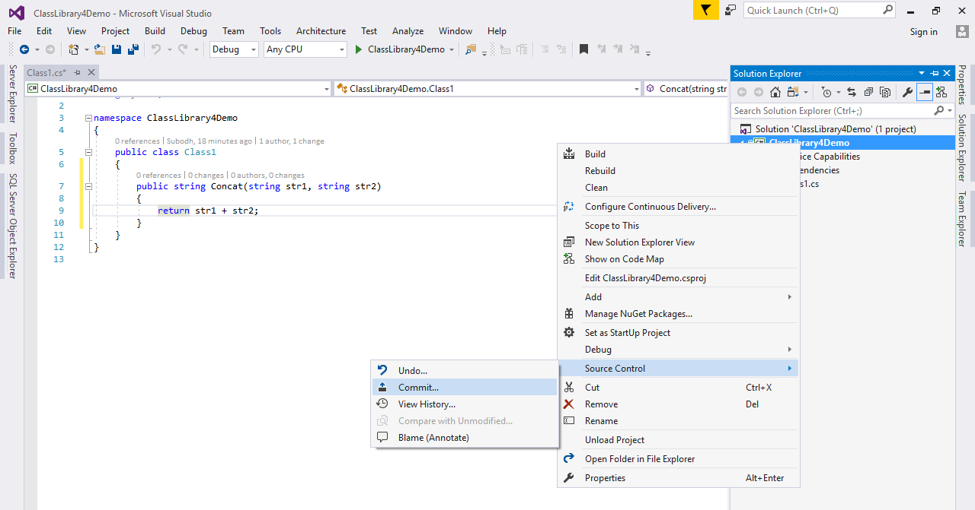

*Figure 3: Commit code to local repository*

After that commit in the bottom right corner of the Visual Studio we will be able to see the status of the local repository. It shows that we are working in the master branch of the local repository and there are 3 commits that are not yet published. If we want to share this project with our team members we will need to publish it to a shared repository like VSTS Git repository.

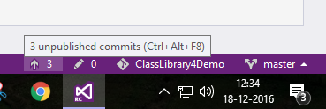

*Figure 4: Status of local repository in Visual Studio*

We may have a team project that uses Git or we can create a new one and connect to that team project in Visual Studio. Once that team project is ready, we will start the publication of our local repository to the remote repository that is created when the team project is created. To link these repositories, we will use the Sync operation.

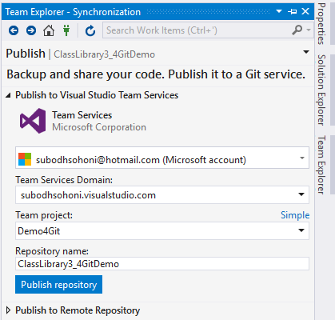

*Figure 5: Publish repository to VSTS Team Project*

This operation first will use our authentication credentials to check available repositories under various team projects for our account in VSTS. It will show all the team projects that use git and then allow us to select the team project and the repository under that.

To view the remote repository mapped to the local repository, in the team explorer we will select the Settings and then Git Settings.

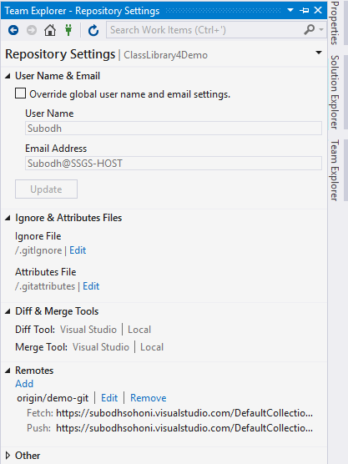

*Figure 6: Git settings and linked remote repositories*

Let us now step through another scenario. In this we will create a branch of master and then create another remote branch in the same repository. To create a branch of master, we will open the Branches tab in the team explorer. BY right clicking on the master, we can create a new local branch. This local branch has all the contents which are in master at this moment. We will now publish this branch so that a remote for it will be created.

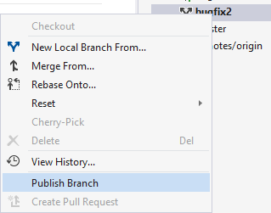

*Figure 7: Publish a newly created branch*

We can create and publish as many branches as needed in the same repository. When we checkout a branch that becomes the active branch in which we can add edits by commits.

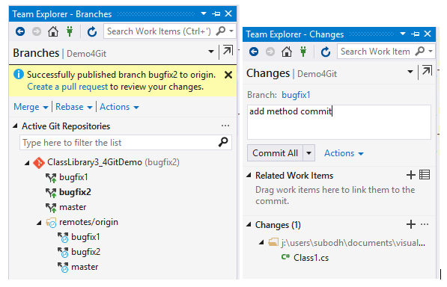

*Figure 8: Add a temporary brnach and make commits to it*

After the edits are over we can push those to the remote repository on VSTS.

These pushed changes can be merged into master branch but before this merge it is a best practice to get the code reviewed by your peers. In git this process of requesting and providing the code review is implemented as featured called ‘pull request’. This feature of VSTS is available from the web interface and not from the Visual Studio. So we open the web interface for the same team project in which we have the repository. Under the Code section of that team project we will find the subsection for Pull Request. Since this is the first time that a pull request is to be created, the page will show the button to create New Pull Request.

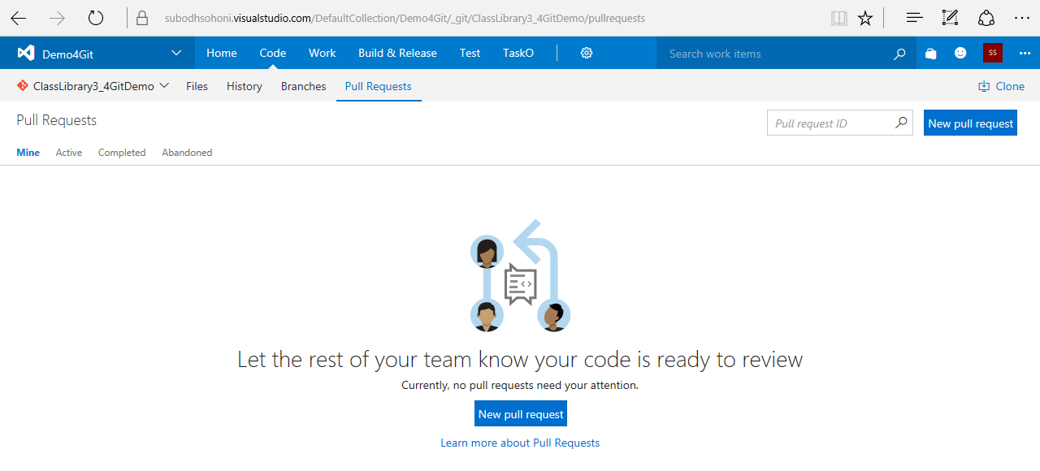

*Figure 9: Create new Pull Request*

For creating the new pull request, we have to specify which branch should be reviewed and how does it defer from any other branch. So we compare code between say branch bugfix1 with the code of master branch.

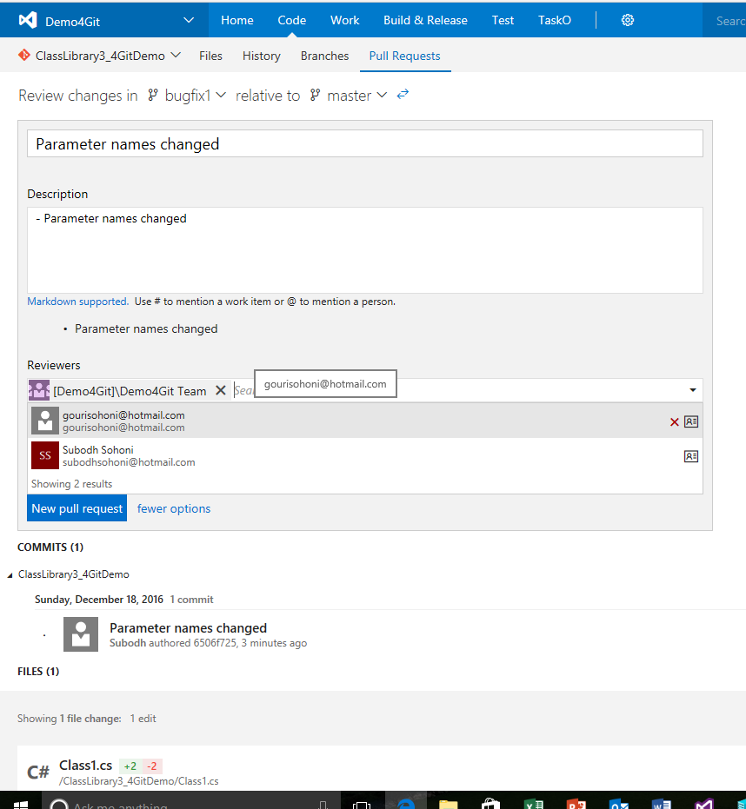

*Figure 10: New pull request*

The commit and the comment while that commit was made are automatically detected and accordingly mentioned on the Pull Request form. We can change the description by using markdown code. We can also provide the names of the reviewers.

Reviewers will be able to see the pull request that they have received. They can view the various perspectives to that pull request like, overview

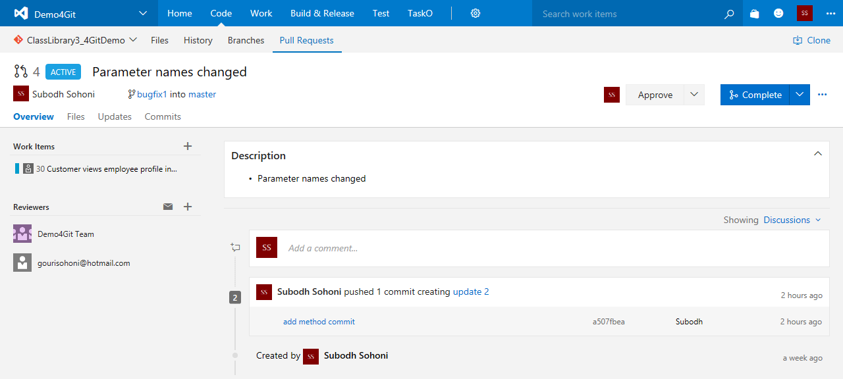

*Figure 11: New pull request overview*

Files, that show the differences between the files in selected branches

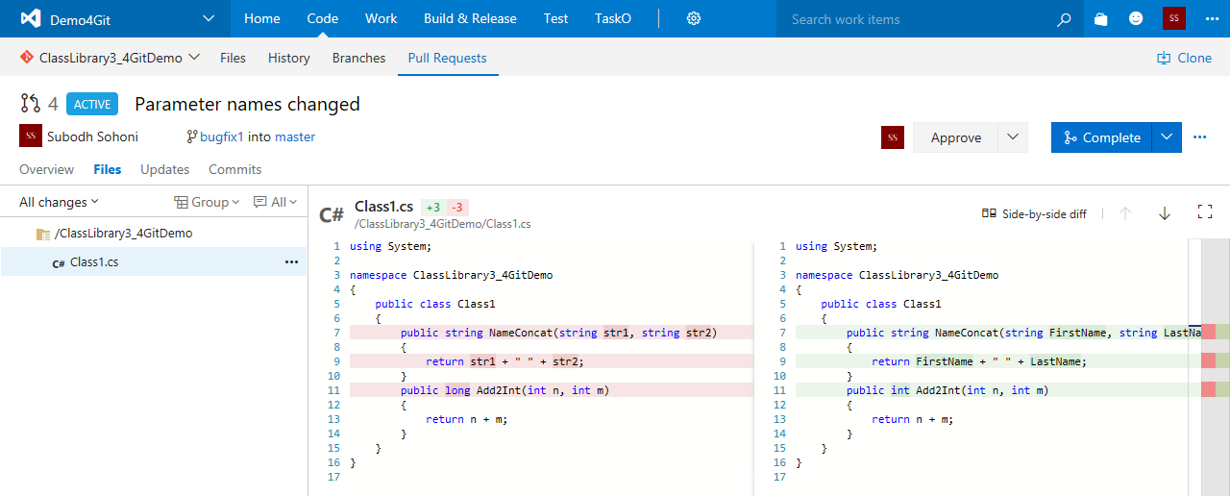

*Figure 12: Pull Request files comparison*

They can comment in the code

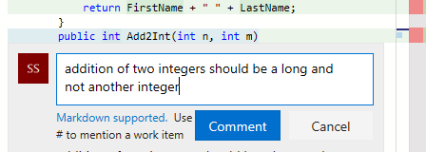

*Figure 13: Add comments in code through pull request.*

They can also view Updates and commits done in the branch that is under the review.

After the review is done code can be Approved, Approved with Suggestions, wait for author (to make necessary changes) or Reject the code.

After the code is Approved by the reviewers, the pull request is completed. Completion of pull request merges the selected branches say from bugfix1 into master branch.

Summary: In this article, we have seen two features of VSTS Git. First, we checked how to add a solution or project to existing repository on the VSTS. We then took an overview of pull request features which facilitates code review before the code is merged from a temporary branch into a master or a release branch.